Name: ____________________________________
Mrs. Bojsa/Miss Bert
English 7A/7R

So, you have a poem in front of you. How do you analyze it? It’s simple! Follow these steps:

- Title: Does the title have any significance?
- Tone: What is the overall tone of this poem? (The tone is the author’s attitude towards his/her subject.)
- Who is speaking?
- What “tools” is the author using? Any repetition? Imagery? Rhyme scheme? Symbolism? Etc.
- Now, put it together! What does this all mean?

Poetic Devices:

- Personification: When non-human objects are given human qualities or characteristics. Example: The sun smiled down on us.

- Simile: A figure of speech involving a comparison between unlike things using like, as, or as though. Example: My love is like a red, red rose.

- Symbol: An object or action in a literary work that means more than itself, that stands for something beyond itself. Example: A heart represents love.

- Tone: The implied attitude of a writer toward the subject and characters of a literary work. Example: humorous, enthusiastic, tense, sarcastic, serious, admiring, objective…

- Hyperbole: A figure of speech involving exaggeration. Example: I am so hungry, I could eat a horse.

- Imagery: When the author creates “mental pictures” that readers experience with a passage of literature. Imagery may include: visual, auditory (sound), tactile (touch), thermal (heat/cold), olfactory (smell), and gustatory (taste).

- Metaphor: A comparison between essentially unlike things without an explicitly comparative word such as like or as. Example: My love is a red, red rose.

- Mood: The feeling, emotional state, or disposition of mind created for the reader when he or she reads a literary work. Mood words: fearful, guilt, relaxed, anxious, romantic, peaceful, cheerful…

- Onomatopoeia: The use of words to imitate the sounds they describe. Example: Buzz, crack, and boom.

- Theme: Main idea/message of the text.

Poem Structure:
- Couplet: A pair of rhymed lines that may or may not make up a separate stanza in a poem.
- Stanza: A division or unit of a poem that is repeated in the same form – either with similar or identical patters of rhyme or with variations from one stanza to another.
- Rhyme Scheme: When the last word in the line of a poem rhymes with another last word in a set pattern- this creates rhythm.
- Rhyme: The matching of final vowel or consonant sounds in two or more words.
- Free Verse: An open form of poetry that does not use any consistent meter, patterns, rhyme or any other musical patterns.
- Sonnet: A poem of fourteen lines using any of a number of formal rhyme schemes, in English typically having ten syllables per line.

Spotlight on Li-Young Lee (1957-):

Even though Lee is Chinese, he never lived in China. Because of his father’s politics, his parents were exiled before he was born. Lee was born in Indonesia, but in 1958 his father was taken as a political prisoner and again exiled. Over the next five years, the Lee family lived in Hong Kong, Macau, and Japan, and finally moved into the US in 1964. He found it hard to adjust to life in the US and actually didn’t talk for a while because he was embarrassed that he couldn’t speak English (www.bpe.org).

I Ask My Mother To Sing
Li-Young Lee

1 She begins, and my grandmother joins her.
Mother and daughter sing like young girls.
If my father were alive, he would play
His accordion and sway like a boat.

5 I’ve never been in Peking, or the Summer Palace,
Nor stood on the great Stone Boat to watch
The rain begin on Kuen Ming Lake, the picnickers
Running away in the grass.

But I love to hear it sung,
10 How the water lilies fill with rain until
They overturn, spilling water into water,
Then rock back, and fill with more.

Both women have begun to cry.
But neither stops her song.

What are water lilies?

“I Ask My Mother To Sing” Questions:

- Who is “she” in line one?

- Interpret lines 10-13.

- How would you describe the tone of this poem? What evidence supports this?

- Why does the author like to hear his mother and grandmother sing?

- What makes the mother and grandmother cry?

- Why don’t the mother and grandmother stop singing?

- Identify an example of imagery.

8. What is a sonnet?

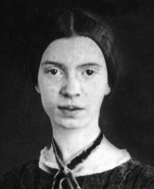

About Emily Dickinson (1830-1886):

Dickinson was born in Amherst, Massachusetts and studied at Amherst Academy from 1840-1847. Emily is one of the most well known American poets and is mostly known for living her life in simplicity and seclusion. After she died, her sister Vinnie found hundreds of her poems and published them. Her fame grew from there. (www.biography.com.)

I’m nobody! Who are you?
Are you nobody, too?
Then there’s a pair of us- don’t tell!
They’d banish us, you know.

How dreary to be somebody!
How public, like a frog
To tell your name the livelong day
To an admiring bog¹!

1 bog: wet, muddy ground that cannot support heavy weight.

- Describe the tone of this poem?

- Identify the simile and its purpose.

- How is a frog “public”?

- Identify Dickinson’s use of personification.

- Define irony? How is irony used in this poem?

Analyze the following poem:

The Courage That My Mother Had
By Edna St. Vincent Millay

The courage that my mother had
Went with her, and is with her still:
Rock from New England quarried;
Now granite in a granite hill.

The golden brooch my mother wore
She left behind for me to wear
I have no thing I treasure more:
Yet, it is something I could spare.

Oh, if instead she’d left to me

The thing she took into the grave! –
That courage like a rock, which she
Has no more need of, and I have.

About Edna St. Vincent Millay (1892-1950):

Millay was born in Rockland, Maine and was raised by a single mother, Cora, along with two other sisters. Cora asked her husband to leave the home in 1899. Millay and her sisters were raised to be ambitious and self-sufficient. After moving to New York, she married in 1923 to Eugen Boissevain, a feminist who gave up his career to manage her literary career. She died in 1950. (www.poets.org.)

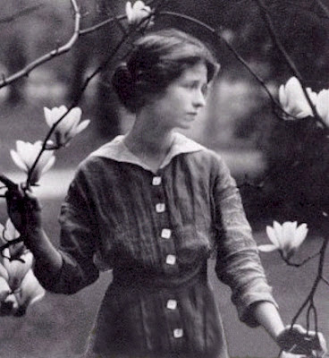

Construct a short response that addresses the following questions:

In the second stanza Millay says “I have no thing I treasure more: Yet, it [the brooch] is something I could spare”. If Millay loves the brooch so much, why would she give it up? Discuss the symbolism of the brooch.

Within this poem, she addresses a very important message: there are some things that cannot be bought. Can you make a connection with this message? Is there anything you wish you possessed that money cannot buy?

_________________________________________________________________________________________________
_________________________________________________________________________________________________
_________________________________________________________________________________________________
_________________________________________________________________________________________________
_________________________________________________________________________________________________
_________________________________________________________________________________________________
_________________________________________________________________________________________________
_________________________________________________________________________________________________
_________________________________________________________________________________________________
_________________________________________________________________________________________________
_________________________________________________________________________________________________
_________________________________________________________________________________________________
_________________________________________________________________________________________________
_________________________________________________________________________________________________
_________________________________________________________________________________________________
_________________________________________________________________________________________________
_________________________________________________________________________________________________
Who is Langston Hughes?

Langston Hughes was born on February 1, 1902 in Joplin, Missouri and died in 1967. His grandmother raised him after his parents split up. However, he moved to Mexico with his father after he graduated high school. Later on, Hughes went to Columbia University, but left after one year to travel the world. Hughes is known as one of the most profound poets and writers in America. (www.biography.com).
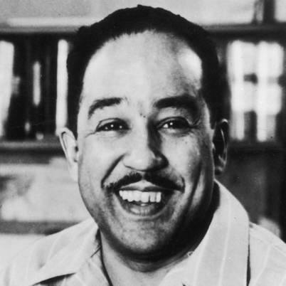

Dreams
By Langston Hughes

Hold fast to dreams
For if dreams die
Life is a broken-winged bird
That cannot fly.

Hold fast to dreams
For when dreams go
Life is a barren field
Frozen with snow.

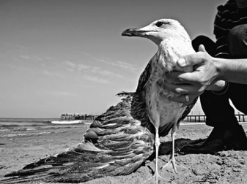

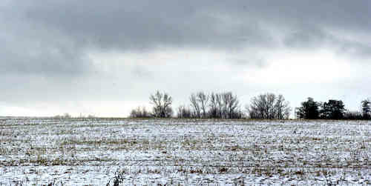

Do Now:
What is the importance of setting goals? Discuss three different goals you have for yourself.
- “Life is a broken-winged bird that cannot fly” is an example of:
A. Simile B. Irony
C. Metaphor D. Onomatopoeia

- “Life is a barren field / Frozen with snow” What does barren mean?
A. Plentiful B. Unable to produce vegetation/life
C. Ugly D. None of the above

- What is the overall theme of the poem?
A. Always try to achieve your dreams B. Life is hard
C. Dreams can run away from you D. Most people don’t dream

- Which of the following poetic devices does Hughes employ in this poem?
A. Imagery B. Sonnet
C. Hyperbole D. Simile

- Which word best describes the overall tone of the poem?
A. Sad B. Exciting
C. Inspirational D. Scary

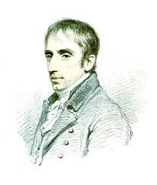
About William Wordsworth:

Wordsworth was born in 1770 in Cumberland. He was a major poet in the Romantic Era (an artistic, literary, and intellectual movement that originated in Europe). In 1843 he became England’s poet laureate (a poet assigned by government who is expected to compost poems for special events) and died in 1850.

I Wandered Lonely as a Cloud

I wandered lonely as a cloud
That floats on high o’er vales and hills,
When all at once I saw a crowd,
A host, of golden daffodils,
Beside the lake, beneath the trees
Fluttering and dancing in the breeze.

Continuous as the stars that shine
And twinkle on the Milky Way,
They stretched in never-ending line
Along the margin of a bay:
Ten thousand saw I at a glance
Tossing their heads in ¹ sprightly dance.

The waves beside them danced, but they
Out-did the sparkling waves in glee: -
A poet could not but be ² gay
In such a ³ jocund company:
I gazed- and gazed- but little thought
What wealth the show to me had brought.

For ⁴ oft, when on my couch I lie
In vacant or in ⁵ pensive mood,
They flash upon the inward eye
Which is the bliss of solitude;
And then my heard with pleasure fills
And dances with the daffodils.

^{1 Sprightly: energetic, lively}
^{2 Gay: Happy}
3 Jocund: Cheerful and lighthearted
^{4 Oft: Short for often}
^{5 Pensive: thoughtful}

Answer the following questions from the poem, “I Wandered Lonely as a Cloud”.

- “When all at once I saw a crowd, / A host of golden daffodils”. In this context, what does the term “host” mean?
A. Someone who entertains B. A group
C. A type of food D. A religious term

- In the following line, “Along the margin of a bay” (line 10), what does “margin” mean?
A. The outskirts/border B. The side of loose-leaf paper
C. Skyline D. Type of water

- Which literary device could be found in the title, “I Wandered Lonely as a Cloud”?
A. Alliteration B. Hyperbole
C. Onomatopoeia D. Simile

- Using textual evidence, what is the overall tone of the poem?

____________________________________________________________________________________
____________________________________________________________________________________
____________________________________________________________________________________________________________________________________________________________________________________________________________________________________________________________
- There is a lot of imagery within this poem! Choose one example that you like the most and write it here:

_______________________________________________________________________________________________________________________________________________________________________
After recording an example of imagery, on a separate piece of paper, illustrate that example with a picture (may be hand drawn, a collage, clip art, etc.) that will be handed in tomorrow for homework. This will be graded, so make it beautiful!!!

Ode to Family Photographs
By Gary Soto

Mama was never good at pictures.

This is a statue of a famous general who lost an arm,
And this is me with my head cut off.

This a trash can chained to a gate,
This is my father with his eyes half-closed.

This a photograph of my sister
And a giraffe looking over her shoulder.

This is our car's front bumper.
This is a bird with a pretzel in its beak.
This is my brother Pedro standing on one leg on a rock.
With a smear of chocolate on his face.

Mama sneezed when she looked
Behind the camera: the snapshots are blurry,
The angles dizzy as a spin on a merry-go-round.

But we had fun when Mama picked up the camera.
How can I tell?
Each of us laughing hard.
Can you see: I have candy in my mouth.

- Who is the speaker of this poem?

- List three examples of imagery and describe their purpose.

- Why do you think Soto talks about pictures for this poem?

- What is the mood of this poem?

- Describe a family photograph of yours that may relate to this poem.

Your final project for this poetry unit is to write your very own poem!

Using Gary Soto’s poem “Ode to Family Photographs” as inspiration, bring in your own family photograph that is appropriate to write about in class. You will need to bring this photo to class every day that we are working on this otherwise you will not get credit for the day!

For this poem keep in mind all that we have discussed throughout this unit:
- Imagery – the 5 senses
- Similes
- Metaphors
- Format (stanzas)
- Theme/Message/
- Tone/Mood

Extra credit will be given to anyone who would like to present his or her poem to the class!

Directions: When reading the passages, place a check mark in the appropriate box to indicate which one of the 5 senses the passage refers to (there may be multiples).

Passage: Sight Sound Smell Touch Taste

“I sniff the apples and cinnamon pie and let its smooth texture melt in my mouth.”

“Beep, Beep!” The horn blew into my ears.

“The silky dress slipped right on.”

“Clouds drift in the bright blue sky, momentarily covering the golden sun.”

“The baby’s cries were so loud, the whole town could hear!”

“Within the first lick of my cone, the soft vanilla ice cream successfully chilled me on this hot summer day.”

